U.S. DEPARTMENT OF THE TREASURY | BUREAU OF THE FISCAL SERVICE

**Monthly Treasury Statement­**

Receipts and Outlays of the United States Government

October2017

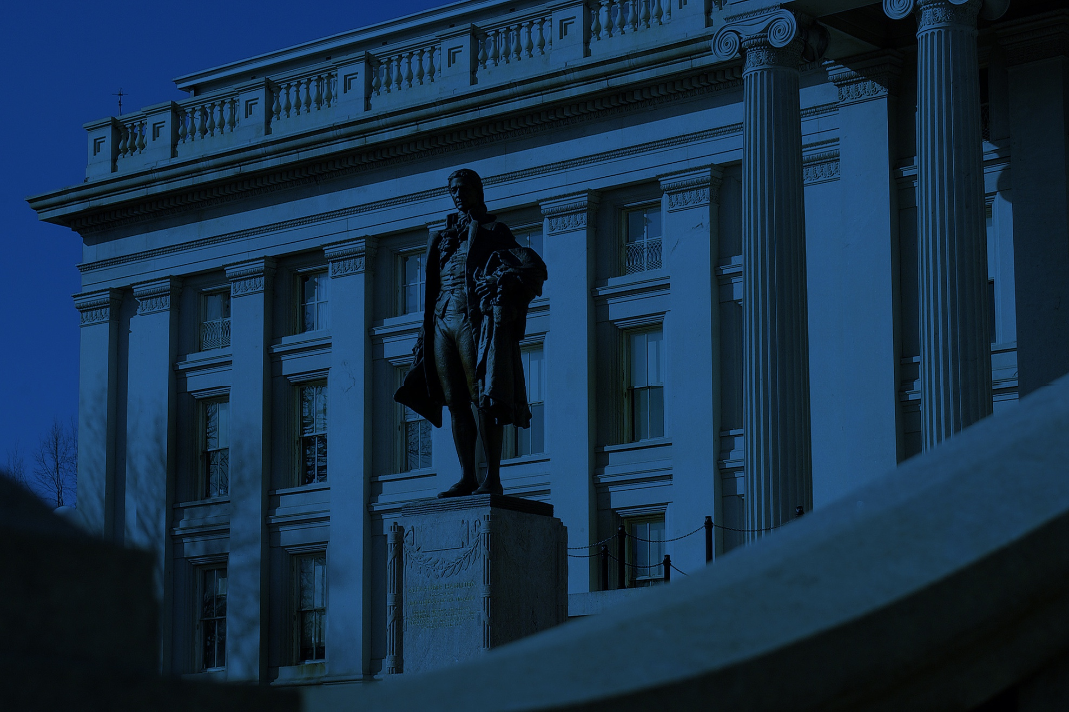

Photo by: Karen Nutini



**Hello!**

The purpose of this document is to provide a cover design and styles for the Monthly Treasury Statement. We understand there are limitations with the software used to output the report. When there is the possibility to fine-tune the fonts, we recommend the styles below to offer a structured, professional and clean look to the report.

**Font: Arial**

Below are the recommended sizes and styles to use in your report. The cover design and styles are exempt from this guidance.

Headline 1 [Arial, 22 points, black]

**Headline 2** [Arial Bold, 18 points, black]

**Headline 3** [Arial Bold, 14 points, black]

Body Copy [Arial, 11 points, black]

**Table Header** [Arial Bold, 10 points, black]

Table Copy [Arial, 10 points, black]

*Footnote* [Arial, 10 points, black]

**How to Insert the New Cover Design:**

(You will need Adobe Acrobat Pro)

1. Openthe source file called: **Treas_BFS_MTS_Cover_092517.docx**
2. Edit the new date on the cover page
3. Go to **File** > **Save As** > in **File Format** dropdown> select **PDF** >click **Save** button

Next….

1. Open the auto-generated MTS report as a PDF in Adobe Acrobat Pro
2. Go to **View** > **Show/Hide** > **Navigation Panes** > **Page Thumbnails**
3. In the left sidebar, click on **Page 1** thumbnail > right click > **Delete Pages**. This will delete the auto-generated cover page 1, be sure you are not deleting a part of the report (E.g. Highlight)

Next…

1. Go to new cover page, go to **View** > **Show/Hide** > **Navigation Panes** > **Page Thumbnails**
2. In the left sidebar, click on **Page 1** thumbnail > with your mouse, drag the new cover design over Page 1 of the MTS report and let go of your mouse. The new page design should now be Page 1 in the MTS report.
3. **Save**

**For Additional Questions:** Justin.Marsico@fiscal.treasury.gov